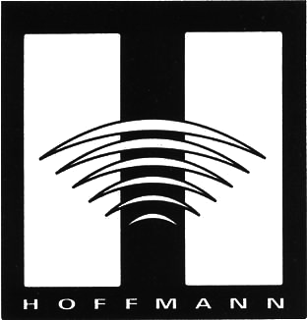
The difference is the sound!
HOFFMANN AMPLIFICATION
Price List

VALKYRIE 65 WATT/THREE CHANNEL HEAD $ 2,200.00
• Three-channel, clean, crunch and overdrive class A/B head featuring (2) EL 34’s, (5) 12 AX7A and (1) 5AR4 Rectifier Tube. 13-ply birch cabinet. Special colors upon request.
COMBO with 2x12 CELESTIONS $2900.00

HOFFMANN 15 $1,500.00
• Class A/B 15-watt head with one channel, overdrive. Vintage sound at its best. With (2) EL84s, (3) 12AX7As, (1) 5Y3. 13 ply birch cabinet. Special colors upon request.
SPECIAL COPPER CHASSIS $1,650.00

MODEL 3C $1,750.00
• Three-channel switch-able preamp (Clean, Lead and Overdrive) with (5) 12Ax7 Tubes. Available in rack-mount.
• Channel 1 is clean with lots of punch.
• Channel 2 gives a well rounded over driven crunch.
• Channel 3 is full out with rich harmonics.
As with all products, this unit features selected high quality components. Hand built in the USA. The difference is the sound!

MODEL 2T POWER AMP $1,500.00 • 65 watt power amp features (2) EL34s, (1) Triode/Pentode driver phase inverter. (1) 5AR4 rectifier, volume control, wide bandwidth output. 13 ply birch cabinet or rack mount available. Special colors upon request.

SPEAKER CABINETS
• 1 x 12” ported cabinet with Celestion G12M75 or Vintage 30 speaker.
Black finish $550.00
Natural birch finish $625.00

THE RIGLER $1,850.00
This 6 channel preamp has separate EQ for each channel (treble, middle & bass). This was designed for Eric Rigler, world-renowned Bagpiper, whose credits include: Million Dollar Baby, Titanic, Braveheart and various television shows and commercials. He also tours with his Celtic group, Bad Haggis. This unit can be used for any wind instrument or as a microphone preamp.
Three-channel single rack space version of The Rigler with toroid transformer $1,250.00

